Spam Email Detection using Machine Learning
Responsible AI & Mode l Interpretation
Project Report
Submitted by: Aishwarya Manohar Rane
Course: CSE (AI & ML)
Tools Used: Python, scikit-learn, LIME, Google Colab

1. Introduction
Spam emails and SMS messages remain one of the most persistent nuisances in digital communication, ranging from harmless advertising to phishing attempts that put users at financial and security risk. This project builds a machine learning model that automatically classifies text messages as either “hum” (legitimate) or “spam”, and goes a step further by examining the model through a Responsible AI lens.
Beyond raw accuracy, the project focuses on interpretability and fairness: understanding which words drive the model's decisions, explaining individual predictions in a human-readable way using LIME (Local Interpretable Model-agnostic Explanations), checking the dataset for class imbalance, and proposing concrete steps to make the system more reliable and fair before it is deployed.

2. Objective
The objective of this project is to:
- Build a text classification model that distinguishes spam messages from legitimate (ham) messages.
- Analyze which features (words) most strongly influence the model's spam predictions.
- Explain individual model predictions in an interpretable way using LIME.
- Check the dataset and model for potential bias arising from class imbalance.
- Propose practical, actionable steps to mitigate identified bias and improve reliability.

3. Dataset Description
The dataset used is the well-known SMS Spam Collection dataset, sourced from a public GitHub repository as a tab-separated (.tsv) file containing two columns: label (ham or spam) and message (the raw SMS text).
url = "https://raw.githubusercontent.com/justmarkham/pycon-2016-tutorial/master/data/sms.tsv"
urllib.request.urlretrieve(url, "spam_dataset.tsv")
After loading the data into a pandas DataFrame with columns ["label", "message"], the dataset was inspected for size and quality:
Number of rows: 5572
label message
0 ham Go until jurong point, crazy.. Available only ...
1 ham Ok lar... Joking wif u oni...
2 spam Free entry in 2 a wkly comp to win FA Cup fina...
3 ham U dun say so early hor... U c already then say...
4 ham Nah I don't think he goes to usf, he lives aro...
The raw dataset contains 5,572 messages with no missing values, but 403 duplicate rows, which were removed prior to modelling.

4. Data Preprocessing
Data preprocessing focused on cleaning the dataset and preparing the target variable for modelling.
print("Missing values:")
print(df.isnull().sum())
print("\nDuplicate rows:", df.duplicated().sum())
df = df.drop_duplicates().reset_index(drop=True)
Missing values:
label 0
message 0
dtype: int64
Duplicate rows: 403
Rows after removing duplicates: 5169
The categorical labels ("ham"/"spam") were also mapped to numeric form (0 for ham, 1 for spam) to make them usable by scikit-learn's classifiers.

5. Train-Test Split
The cleaned dataset was split into training and testing subsets using an 80/20 split, with stratification on the label to preserve the original class ratio in both sets.
X = df["message"]
y = df["label"].map({"ham": 0, "spam": 1})
X_train, X_test, y_train, y_test = train_test_split(
X, y, test_size=0.20, random_state=42, stratify=y
)
Training samples: 4135
Testing samples: 1034

6. TF-IDF Feature Extraction
Since machine learning models require numeric input, the raw text messages were converted into numerical feature vectors using TF-IDF (Term Frequency–Inverse Document Frequency), which weights words by how distinctive they are to a message relative to the whole corpus. English stop words were removed and the vocabulary was capped at the 5,000 most informative terms.
tfidf = TfidfVectorizer(stop_words="english", max_features=5000)
X_train_tfidf = tfidf.fit_transform(X_train)
X_test_tfidf = tfidf.transform(X_test)
Training feature shape: (4135, 5000)
Testing feature shape: (1034, 5000)

7. Logistic Regression Model
A Logistic Regression classifier was trained on the TF-IDF features. Logistic Regression was chosen for this Responsible AI task because, unlike “black box” models, its coefficients directly and transparently indicate how strongly each word pushes a prediction toward spam or ham.
lr_model = LogisticRegression(max_iter=1000)
lr_model.fit(X_train_tfidf, y_train)
Logistic Regression model trained successfully!

8. Model Performance
The trained model was evaluated on the held-out test set using accuracy and precision as the primary metrics.
y_pred = lr_model.predict(X_test_tfidf)
accuracy = accuracy_score(y_test, y_pred)
precision = precision_score(y_test, y_pred)
Metric | Value
Accuracy | 95.84%
Precision (Spam class) | 97.83%
The high precision score indicates that when the model flags a message as spam, it is correct about 98% of the time — an important property for a spam filter, since misclassifying a legitimate message as spam (a false positive) is generally more costly to the user than missing a spam message.

9. Feature Importance Analysis
Because Logistic Regression is a linear model, its learned coefficients can be directly interpreted as feature importances: a large positive coefficient for a word means that word strongly pushes a message toward being classified as spam.
feature_names = tfidf.get_feature_names_out()
coefficients = lr_model.coef_[0]
feature_importance = pd.DataFrame({
"Feature": feature_names, "Importance": coefficients
})
top_spam = feature_importance.sort_values(
by="Importance", ascending=False
).head(15)
The top 15 words most strongly associated with spam were: txt, mobile, www, uk, claim, reply, free, text, stop, 150p, prize, 50, service, new, and com — vocabulary typical of promotional offers, premium-rate services, and prize-scam messages.
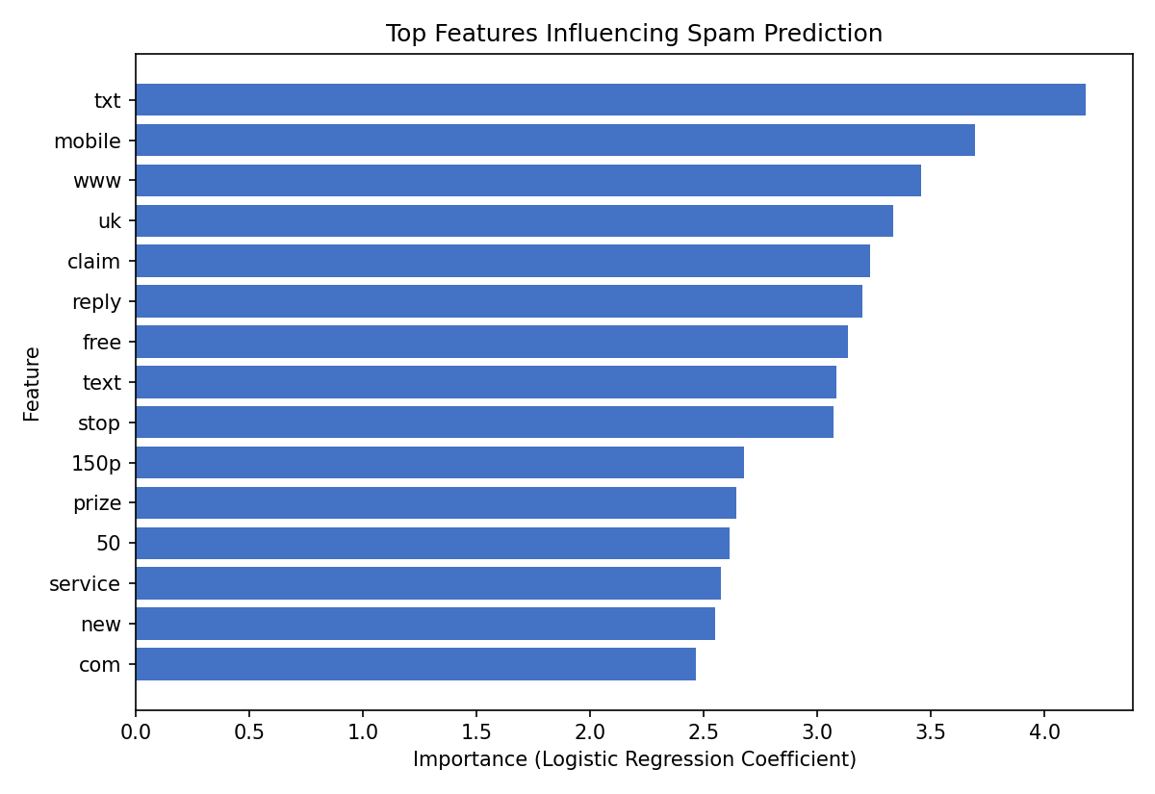

10. LIME Model Explanation
While feature importance reveals what the model has learned overall, it does not explain any single prediction. LIME (Local Interpretable Model-agnostic Explanations) was used to explain individual predictions by locally approximating the model's decision boundary around a specific message and reporting which words pushed that particular prediction toward ham or spam.
explainer = LimeTextExplainer(class_names=["Ham", "Spam"])
def predict_proba(texts):
texts_tfidf = tfidf.transform(texts)
return lr_model.predict_proba(texts_tfidf)
explanation = explainer.explain_instance(
sample_message, predict_proba, num_features=10
)
For the sample test message — a personal, affectionate good-morning text — the model correctly predicted HAM with high confidence.
Test message: "Good morning, my Love ... I go to sleep now and wish you a great day full of feeling better and opportunity ... You are my last thought babe, I LOVE YOU *kiss*"
Model Prediction: HAM
Prediction probabilities — Ham: 0.98, Spam: 0.02
Top contributing words (LIME):
Good : -0.0053
day : -0.0042
thought : -0.0042
morning : -0.0034
Love : -0.0033
feeling : +0.0033
LOVE : -0.0032
great : -0.0028
sleep : -0.0027
opportunity: +0.0025
Negative weights push the prediction toward Ham and positive weights push it toward Spam. The explanation confirms that ordinary, affectionate vocabulary (“Good”, “morning”, “Love”, “sleep”) drove the Ham prediction, while only a couple of more generic words (“feeling”, “opportunity”) contributed weakly toward Spam — giving a transparent, human-readable justification for what would otherwise be a black-box decision.

11. Bias and Class Distribution Check
A model's fairness and reliability are heavily influenced by the balance of its training data. The class distribution of the full dataset was therefore examined:
class_counts = df["label"].value_counts()
class_percentages = df["label"].value_counts(normalize=True) * 100
label
ham 4516 (87.37%)
spam 653 (12.63%)
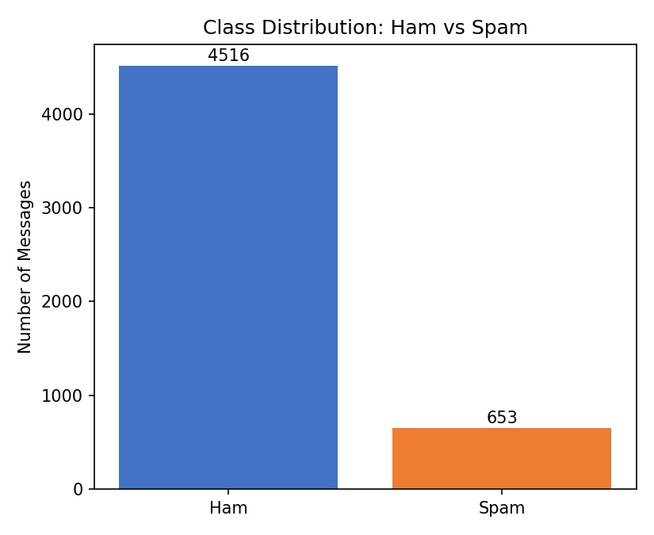
The dataset is noticeably imbalanced, with ham messages outnumbering spam messages by roughly 7 to 1. This kind of imbalance is a common source of bias: models trained on such data can become skewed toward the majority class and may under-detect the minority class (spam) in real-world use, even while reporting high overall accuracy.

12. Bias Mitigation Recommendations
Based on the class imbalance and interpretability findings above, the following practical steps are recommended to improve the reliability and fairness of the spam detection model:
- Use a more balanced dataset containing sufficient examples of both ham and spam messages.
- Remove duplicate, incomplete, and poor-quality messages from the dataset before training.
- Regularly update the dataset with new and emerging types of spam messages.
- Monitor false positives closely, since legitimate messages should not be incorrectly classified as spam.
- Monitor false negatives, since some spam messages may be incorrectly classified as ham.
- Continue using LIME or SHAP explanations to understand which features affect individual predictions.
- If future datasets contain sensitive group attributes, perform group-wise fairness analysis across those groups.
- Retrain and re-evaluate the model periodically as new email and messaging patterns emerge.

13. Results and Findings
- The Logistic Regression model achieved 95.84% accuracy and 97.83% precision on the held-out test set, making it highly reliable at correctly flagging spam without over-flagging legitimate messages.
- The most influential words in spam predictions (txt, mobile, www, claim, free, prize, etc.) closely match the vocabulary typically seen in promotional and scam messages, confirming the model has learned meaningful, sensible patterns rather than spurious correlations.
- LIME explanations showed that individual predictions could be traced back to specific, intuitive words in the message, making the model's behaviour transparent and auditable rather than a black box.
- The dataset exhibits a significant class imbalance (87.37% ham vs 12.63% spam), which is an important caveat when interpreting the headline accuracy figure and a key area for future improvement.

14. Conclusion
This project analyzed a Spam Email Detection model from a Responsible AI perspective rather than focusing on predictive performance alone. A TF-IDF and Logistic Regression pipeline achieved strong accuracy and precision, and feature importance analysis showed that the model's decisions are grounded in intuitive, spam-indicative vocabulary. LIME was used to explain individual predictions in a transparent, human-readable way, and a class distribution check revealed a notable imbalance between ham and spam messages in the dataset.
Together, these steps demonstrate that a well-performing model is not automatically a trustworthy one: interpretability and bias analysis are essential complements to accuracy metrics. The mitigation recommendations proposed — dataset balancing, continual monitoring of false positives/negatives, and periodic retraining — provide a practical roadmap for deploying this model more responsibly.

15. References
- SMS Spam Collection Dataset — justmarkham/pycon-2016-tutorial, GitHub.
- Pedregosa et al., “Scikit-learn: Machine Learning in Python,” Journal of Machine Learning Research, 2011.
- Ribeiro, M. T., Singh, S., & Guestrin, C. (2016). “‘Why Should I Trust You?’: Explaining the Predictions of Any Classifier” (LIME paper).
- scikit-learn documentation: TfidfVectorizer and LogisticRegression — scikit-learn.org.
- LIME documentation — marcotcr/lime, GitHub.

